NSCCL Keele University Sports Centre

IMPORTANT: No outdoor running shoes inside the building please

Parking available in all the car parks on the weekend without charge. Almost the entire route is on grass; there is a small section on tarmac where mats will be provided.

For the junior races all races are anticlockwise, and a full lap is approximately 1200m. The juniors’ route is shown below. There are different start points for each of the races, as listed, and the finish for all races will be next to the Sports Centre as marked by the red circle

12:00 U11 girls 1600m (start is point A, run approx. 400m past the finish, then 1 full lap)
12:15 U13 girls U11 boys 1800m (start is point B, run approx. 600m past the finish, then 1 full lap)
12:35 U15 girls U13 boys 3100m (start is point C, run approx. 700m past the finish, then 2 full laps)
13:00 U17 girls U15 boys 4300m (start is point C, run approx. 700m past the finish, then 3 full laps)

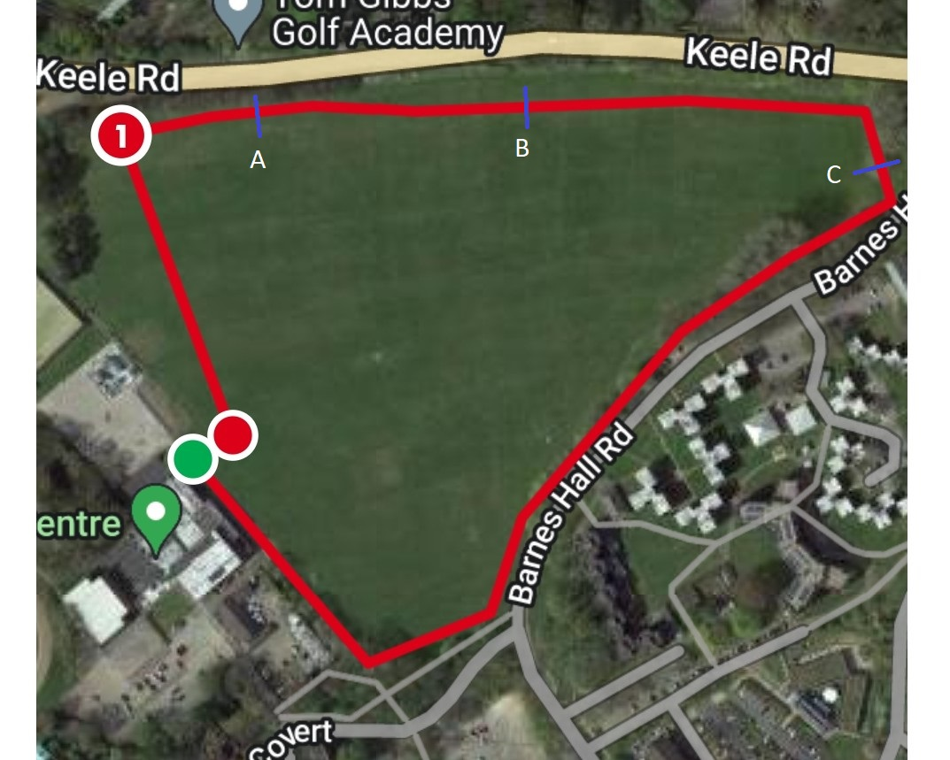

13:30 Senior ladies and junior boys 5000m
14:10 Senior men 7500m

The senior races follow the laps below, ran anticlockwise, the start and finish are next to the Sports Centre. The senior ladies do 2 laps and the senior men 3 laps

